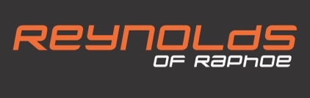
CUSTOMER RETURN
DATE:

MEETINGHOUSE STREET, RAPHOE, CO. DONEGAL RA REF:
TEL: 074 91 45179. EMAIL: INFO@ROR.IE

N.B. RETURNS MUST BE APPROVED BY REYNOLDS OF RAPHOE BY ISSUING A RA NUMBER
CUSTOMER NAME:
ADDRESS:
CONTACT NUMBER: | EMAIL:
BRAND: | MODEL:
SERIAL NO: | PROD. DESCRIPTION:

ARE GOODS UNDER 12 MONTH GUARANTEE: YES/NO
INVOICE/ RECEIPT NO:
DATE OF INVOICE:

IF YES, PLEASE STATE:

NB: REPAIR WILL NOT BE UNDERTAKEN UNDER GUARANTEE IF INVOICE NUMBER / DATE IS NOT PROVIDED
FAULT DESCRIPTION (MUST BE FILLED IN)

FURTHER INFORMATION / ADDITIONAL ITEMS (E.G. FLIGHT CASE, CABLES ETC):

WHEN COMPLETE PLEASE EMAIL BACK TO INFO@ROR.IE
NB: PLEASE NOTE THERE IS A MINIMUM CHARGE OF €30 PLUS VAT ON ALL REPAIR WORK UNDERTAKEN OUTSIDE GUARANTEE (EVEN IF BEYOND ECONOMICAL REPAIR OR IF NO FAULT FOUND ON ITEM UNDER GUARANTEE)
A NON-REFUNDABLE DEPOSIT MAY BE REQUIRED FOR NON ACCOUNT HOLDERS

